
International University of Business Agriculture and Technology
Course Code: CSC 434

Course Name: Database Management System Lab

Project Report:

Football Club Management System

Submitted To
Faniyam Maria Mansia
Lecturer
Dept. of Computer Science & Engineering

Submitted By

Md Fardin Al Shafik

ID: 23203117
Section: F

Summer 2025

Football Club Management System – DBMS Project Report

List of Contents
Football Club Management System – DBMS Project Report 1
Preface 4
Session Objective 4
Theory 4
Topics Covered 4
Theoretical Foundation 4
Coursework No. 1: Database Creation & Schema Design 5
Problem Statement 5
Solution 5
Coursework No. 2: Data Import into Tables 7
Problem Statement 7
Solution 7
Coursework No. 3: Basic Queries & Data Retrieval 8
Problem Statement 8
Solution 8
Coursework No. 4: Aggregate Queries & Joins 9
Problem Statement 9
Solution 9
Coursework No. 5: Index Page Implementation 9
Problem Statement 9
Solution 9
Coursework No. 6: Standings Page 10
Problem Statement 10
Solution 10
Coursework No. 7: Matches Module 12
Problem Statement 12
Solution 12
Coursework No. 8: Squads Module 14
Problem Statement 14
Solution 14
Coursework No. 9: Stats Page 15
Problem Statement 15
Solution 15
Coursework No. 10: Shops Module 16
Problem Statement 16
Solution 16
Coursework No. 11: Dashboard 18
Problem Statement 18
Solution 18
Coursework No. 12: Login & Logout System 19
Problem Statement 19
Solution 19
Ethical Considerations 21
Data Privacy 21
Security and Integrity 21
Fair Use and Transparency 21
Professional Responsibility 22
Ethical Compliance in Future Development 22
Learning Outcomes 22
Understanding of DBMS Concepts 22
SQL Query Skills 23
System Design and Analysis 23
Programming and Implementation 24
Quality Assurance and Testing 24
Ethical and Professional Lessons 24
Chapter 7: Conclusion 24
Limitations 25
Future Scope 26
Referencing 26

Preface
The project report presents the development of a Football Club Management System that integrates various aspects of club administration into a centralized and automated platform. In the current context, most small and medium football clubs manage their data manually, which makes it difficult to track player statistics, match results, injuries, staff information, and merchandise sales effectively. Our proposed system bridges this gap by providing a relational database-driven solution using MySQL, PHP, HTML, and CSS. The system enables CRUD operations for teams, players, staff, matches, users, and shop items, along with injury tracking and role-based authentication for Chairman and Coach. The implementation of relational database principles ensures data integrity, normalization, and ease of reporting. By offering a user-friendly interface and structured data management, this project demonstrates how technology can enhance decision-making, improve transparency, and simplify day-to-day football club operations.

Session Objective
- Design a relational database for football management.
- Implement SQL queries to retrieve and manipulate football data.
- Develop application modules (index, standings, matches, squads, stats, shops, dashboard, login, logout).
- Demonstrate secure database connectivity and transactions.

Theory

Topics Covered
- Database creation and normalization
- CRUD operations
- Aggregations, joins, subqueries
- Views, triggers, procedures
- Web integration with PHP/MySQL

Theoretical Foundation
Relational database principles and modular web design are combined to build the FCMS. Security, role-based access, and data consistency form the foundation of the system.

Coursework No. 1: Database Creation & Schema Design

Problem Statement
Design the schema for a football management system.

Solution
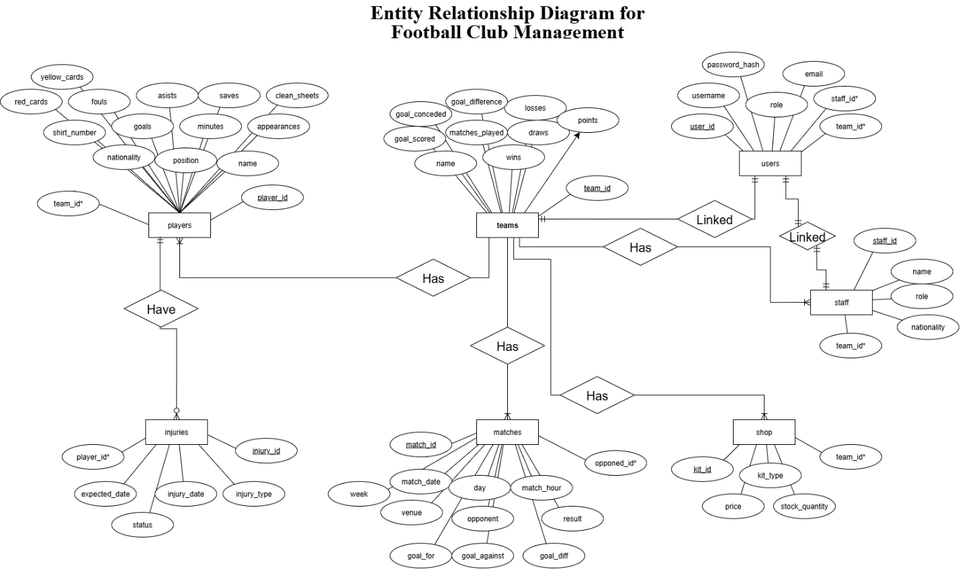
Figure 1: ERD diagram
CREATE DATABASE football_management_system;
USE football_management_system;

CREATE TABLE teams (
team_id INT AUTO_INCREMENT PRIMARY KEY,
name VARCHAR(50),
matches_played INT,
wins INT,
draws INT,
losses INT,
goals_scored INT,
goals_conceded INT,
goal_difference INT,
points INT
);

CREATE TABLE players (
PlayerID INT PRIMARY KEY,
Name VARCHAR(100),
team_id INT,
Position VARCHAR(30),
Nationality VARCHAR(50),
ShirtNumber INT,
appearances INT,
minutes INT,
goals INT,
assists INT,
clean_sheets INT,
Saves INT,
fouls INT,
yellow_cards INT,
red_cards INT,
FOREIGN KEY (team_id) REFERENCES teams(team_id)
);

CREATE TABLE matches (
match_id INT AUTO_INCREMENT PRIMARY KEY,
match_date DATE,
day VARCHAR(10),
match_hour INT,
week INT,
venue VARCHAR(10),
gf INT,
ga INT,
opponent VARCHAR(50),
opponent_id INT,
result CHAR(1),
goal_diff INT,
FOREIGN KEY (opponent_id) REFERENCES teams(team_id)
);

CREATE TABLE staff (
staff_id INT AUTO_INCREMENT PRIMARY KEY,
name VARCHAR(100) NOT NULL,
role VARCHAR(50) NOT NULL,
nationality VARCHAR(50),
team_id INT,
FOREIGN KEY (team_id) REFERENCES teams(team_id)
);

CREATE TABLE shop (
kit_id INT AUTO_INCREMENT PRIMARY KEY,
team_id INT,
kit_type VARCHAR(20),
price DECIMAL(10, 2),
stock_quantity INT,
FOREIGN KEY (team_id) REFERENCES teams(team_id)
);

CREATE TABLE users (
user_id INT AUTO_INCREMENT PRIMARY KEY,
staff_id INT NOT NULL,
username VARCHAR(50) UNIQUE NOT NULL,
password_hash VARCHAR(255) NOT NULL,
role ENUM('Chairman', 'Coach') NOT NULL,
email VARCHAR(100) UNIQUE,
team_id INT,
FOREIGN KEY (team_id) REFERENCES teams(team_id),
FOREIGN KEY (staff_id) REFERENCES staff(staff_id)
);

Coursework No. 2: Data Import into Tables

Problem Statement
Populate the tables with initial football-related data.

Solution
INSERT INTO teams (name, matches_played, wins, draws, losses, goals_scored, goals_conceded, goal_difference, points)
(1, 'Liverpool', 38, 25, 9, 4, 84, 39, 45, 84);
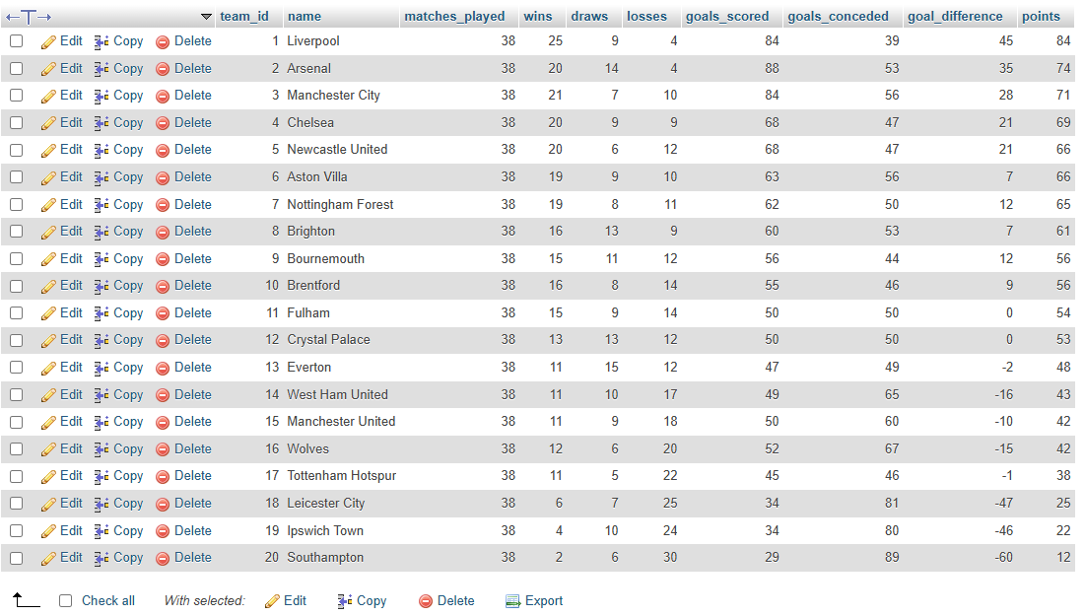

INSERT INTO players (PlayerID, Name, team_id, Position, Nationality, ShirtNumber, appearances, minutes, goals, assists)
(2, 'Alexis Mac Allister', 1, 'MID', 'Argentina', 10, 35, 2607, 5, 5, 9, 0, 62, 6, 0);
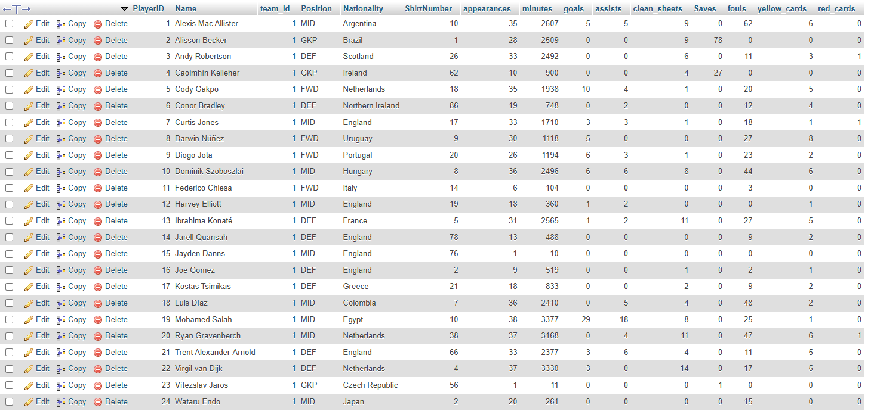

Coursework No. 3: Basic Queries & Data Retrieval

Problem Statement
Fetch team and player data using simple SQL queries.

Solution
SELECT Name, goals FROM players WHERE Position = 'FWD';
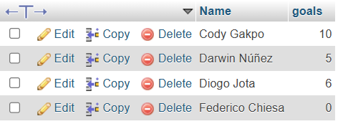
SELECT match_date, day, venue, opponent, gf, ga, result FROM matches ORDER BY match_date DESC;
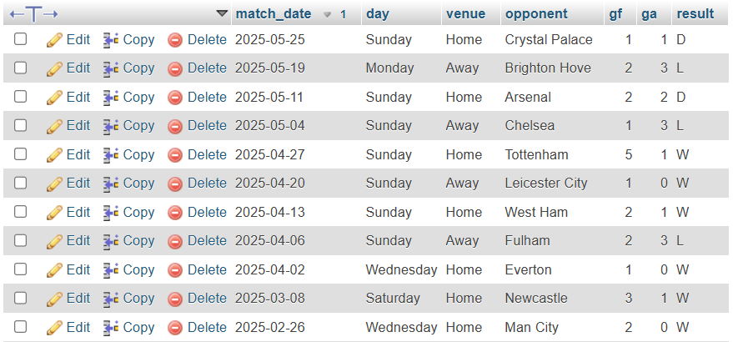

Coursework No. 4: Aggregate Queries & Joins

Problem Statement
Generate standings and statistics using aggregates and joins.

Solution
SELECT s.kit_type, s.price, s.stock_quantity, t.name AS team_name
FROM shop s
JOIN teams t ON s.team_id = t.team_id;
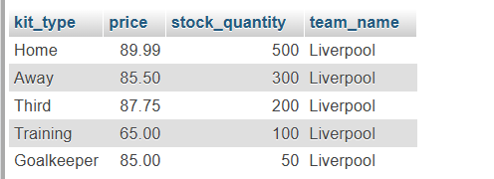

Coursework No. 5: Index Page Implementation

Problem Statement
Design the index page with navigation.

Solution
<?php
require '../config/db.php';
?>
<!DOCTYPE html>
<html>
<head>
<title>Football Club Management</title>
<link rel="stylesheet" href="../css/style.css">
</head>
<body>
<?php include '../includes/header.php'; ?>
<div class="container">
<h1>Liverpool</h1>
<?php include '../includes/club-info.php'; ?>
<?php include '../includes/team-form.php'; ?>
<?php include '../includes/top-performance.php'; ?>
</div>
<?php include '../includes/footer.html'; ?>
</body>
</html>

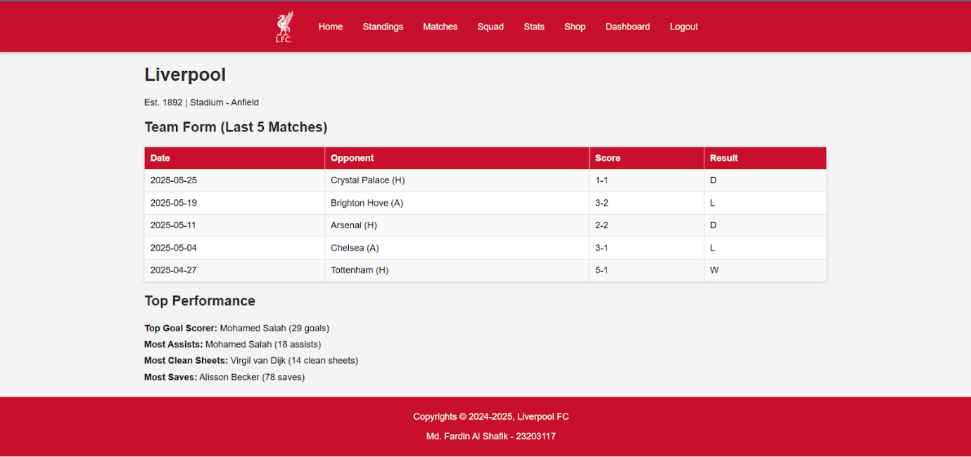
Figure 2: Home Page of project

Coursework No. 6: Standings Page

Problem Statement
Display live standings.

Solution
<?php
require '../config/db.php';

$query = $pdo->query("SELECT name, matches_played, wins, draws, losses, goals_scored, goals_conceded, goal_difference, points FROM teams ORDER BY points DESC");
$teams = $query->fetchAll();
?>

<!DOCTYPE html>
<html>
<head>
<title>League Standings</title>
<link rel="stylesheet" href="../css/style.css">
</head>
<body>
<?php include '../includes/header.php'; ?>
<div class="container">
<h1>League Standings</h1>
<table>
<tr>
<th>#</th>
<th>Team</th>
<th>Played</th>
<th>W</th>
<th>D</th>
<th>L</th>
<th>GF</th>
<th>GA</th>
<th>GD</th>
<th>Points</th>
</tr>
<?php if ($teams) { ?>
<?php $position = 1; foreach ($teams as $team) { ?>
<tr>
<td><?php echo $position++; ?></td>
<td><?php echo $team['name']; ?></td>
<td><?php echo $team['matches_played']; ?></td>
<td><?php echo $team['wins']; ?></td>
<td><?php echo $team['draws']; ?></td>
<td><?php echo $team['losses']; ?></td>
<td><?php echo $team['goals_scored']; ?></td>
<td><?php echo $team['goals_conceded']; ?></td>
<td><?php echo $team['goal_difference']; ?></td>
<td><?php echo $team['points']; ?></td>
</tr>
<?php } ?>
<?php } else { ?>
<tr><td colspan="10">No teams found.</td></tr>
<?php } ?>
</table>
</div>
<?php include '../includes/footer.html'; ?>
</body>
</html>

SELECT name, matches_played, wins, draws, losses, points
FROM teams
ORDER BY points DESC;
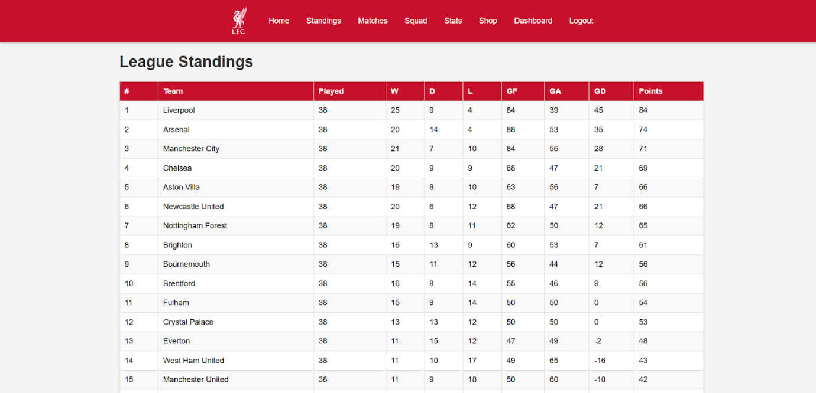
Figure 3: League Standings

Coursework No. 7: Matches Module

Problem Statement
Manage and display fixtures/results.

Solution
<?php
require '../config/db.php';

$query = $pdo->query("SELECT match_date, day, venue, opponent, gf, ga, result FROM matches ORDER BY match_date DESC");
$matches = $query->fetchAll();
?>

<!DOCTYPE html>
<html>
<head>
<title>Matches</title>
<link rel="stylesheet" href="../css/style.css">
</head>
<body>
<?php include '../includes/header.php'; ?>
<div class="container">
<h1>Match History</h1>
<table>
<tr>
<th>Date</th>
<th>Day</th>
<th>Venue</th>
<th>Opponent</th>
<th>Score</th>
<th>Result</th>
</tr>
<?php if ($matches) { ?>
<?php foreach ($matches as $match) { ?>
<tr>
<td><?php echo $match['match_date']; ?></td>
<td><?php echo $match['day']; ?></td>
<td><?php echo $match['venue']; ?></td>
<td><?php echo $match['opponent']; ?></td>
<td><?php echo $match['venue'] == 'Home' ? $match['gf'] . '-' . $match['ga']
: $match['ga'] . '-' . $match['gf']; ?></td>
<td><?php echo $match['result']; ?></td>
</tr>
<?php } ?>
<?php } else { ?>
<tr><td colspan="6">No matches found.</td></tr>
<?php } ?>
</table>
</div>
<?php include '../includes/footer.html'; ?>
</body>
</html>
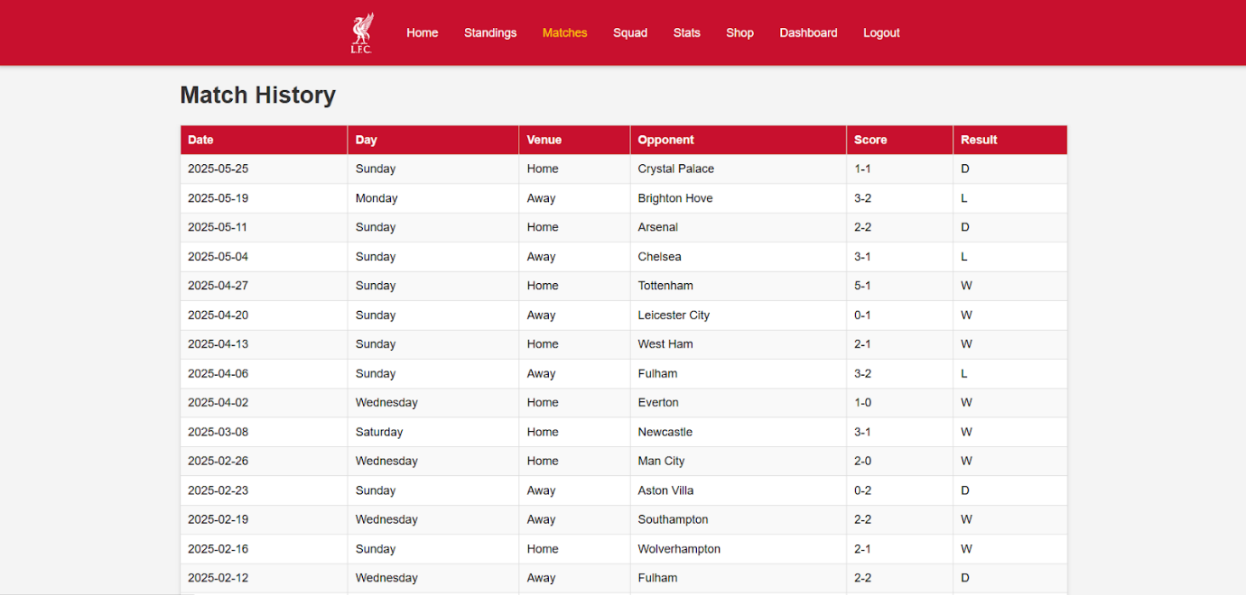
Figure 4: Match History

Coursework No. 8: Squads Module

Problem Statement
List players by team and update injuries.

Solution
<?php
require '../config/db.php';

$coach_query = $pdo->query("SELECT name FROM staff WHERE role = 'Coach' LIMIT 1");
$coach = $coach_query->fetch();
?>

<!DOCTYPE html>
<html>
<head>
<title>Team Squad</title>
<link rel="stylesheet" href="../css/style.css">
</head>
<body>
<?php include '../includes/header.php'; ?>
<div class="container">
<h1>Team Squad</h1>
<?php if ($coach) { ?>
<h2>Head Coach: <?php echo $coach['name']; ?></h2>
<?php } else { ?>
<h2>Head Coach: N/A</h2>
<?php } ?>

<?php include '../includes/gk-players.php'; ?>
<?php include '../includes/def-players.php'; ?>
<?php include '../includes/mid-players.php'; ?>
<?php include '../includes/fwd-players.php'; ?>

<?php include '../includes/injuries-update.php'; ?>
</div>
<?php include '../includes/footer.html'; ?>
</body>
</html>

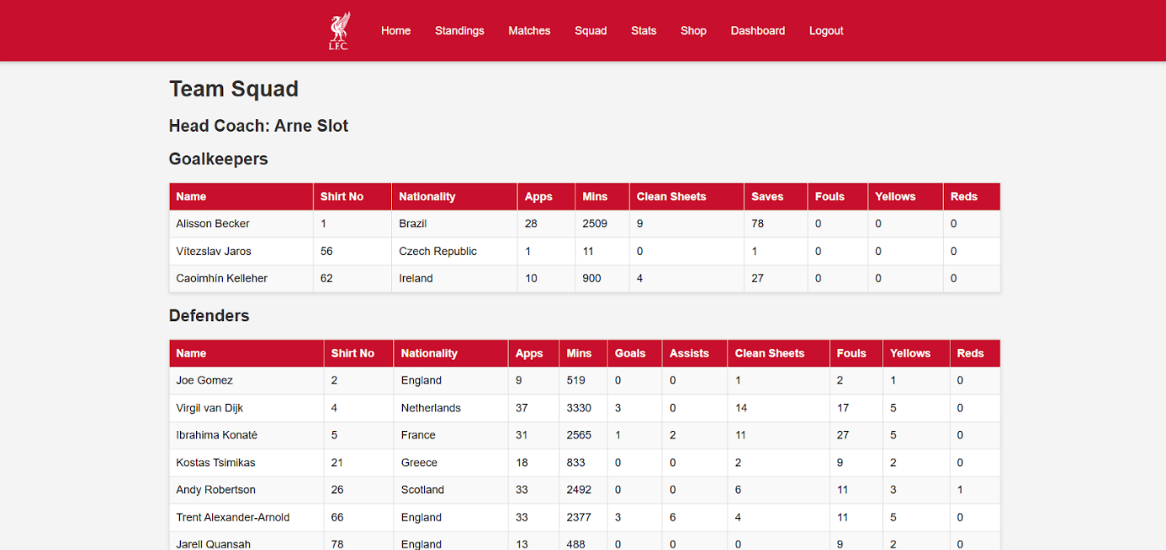
Figure 5: Squad

Coursework No. 9: Stats Page

Problem Statement
Display player and team statistics.

Solution
<?php
require '../config/db.php';
?>
<!DOCTYPE html>
<html>
<head>
<title>Player Stats</title>
<link rel="stylesheet" href="../css/style.css">
</head>
<body>
<?php include '../includes/header.php'; ?>
<div class="container">
<h1>Player Stats</h1>
<h2>Top Performance</h2>
<?php include '../includes/stats-goals.php'; ?>
<?php include '../includes/stats-assists.php'; ?>
<?php include '../includes/stats-goal-contribution.php'; ?>
<?php include '../includes/stats-clean-sheets.php'; ?>
<?php include '../includes/stats-saves.php'; ?>
<?php include '../includes/stats-appearances.php'; ?>
<?php include '../includes/stats-minutes.php'; ?>
<?php include '../includes/stats-fouls.php'; ?>
<?php include '../includes/stats-yellow-cards.php'; ?>
<?php include '../includes/stats-red-cards.php'; ?>
</div>
<?php include '../includes/footer.html'; ?>
</body>
</html>
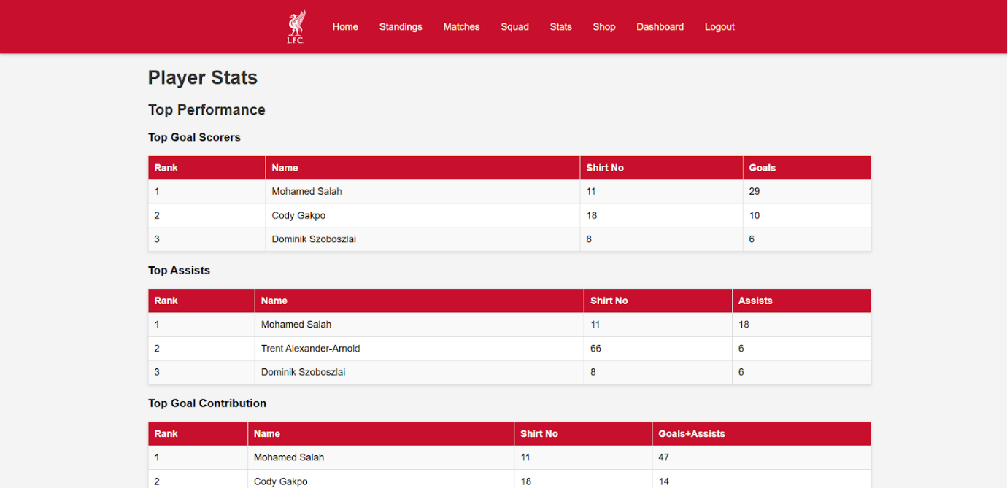
Figure 6: Players Statistics

Coursework No. 10: Shops Module

Problem Statement
Manage football kits and stock.

Solution
<?php
require '../config/db.php';

$query = $pdo->query("SELECT s.kit_type, s.price, s.stock_quantity, t.name AS team_name FROM shop s JOIN teams t ON s.team_id = t.team_id");
$kits = $query->fetchAll();
?>

<!DOCTYPE html>
<html>
<head>
<title>Club Shop</title>
<link rel="stylesheet" href="../css/style.css">
</head>
<body>
<?php include '../includes/header.php'; ?>
<div class="container">
<h1>Club Shop</h1>
<table>
<tr>
<th>Team</th>
<th>Kit Type</th>
<th>Price</th>
<th>Stock</th>
</tr>
<?php if ($kits) { ?>
<?php foreach ($kits as $kit) { ?>
<tr>
<td><?php echo $kit['team_name']; ?></td>
<td><?php echo $kit['kit_type']; ?></td>
<td>$<?php echo number_format($kit['price'], 2); ?></td>
<td><?php echo $kit['stock_quantity']; ?></td>
</tr>
<?php } ?>
<?php } else { ?>
<tr><td colspan="4">No kits available.</td></tr>
<?php } ?>
</table>
</div>
<?php include '../includes/footer.html'; ?>
</body>
</html>
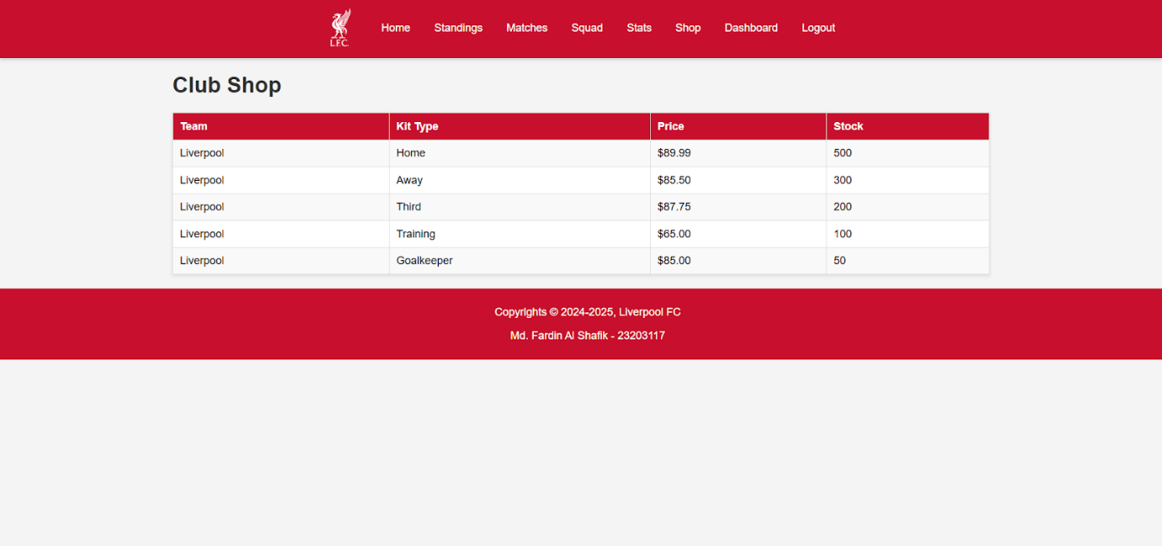
Figure 7: Club Shop

Coursework No. 11: Dashboard

Problem Statement
Provide admin with overview of data.

Solution
<?php
require '../config/db.php';
require '../includes/functions.php';

if (!isLoggedIn()) {
header('Location: login.php');
exit;
}
?>
<!DOCTYPE html>
<html>
<head>
<title>Dashboard</title>
<link rel="stylesheet" href="../css/style.css">
<link rel="stylesheet" href="../css/dashboard.css">
</head>
<body>
<?php include '../includes/header.php'; ?>
<div class="container">
<div class="dashboard-container">
<h1>Dashboard</h1>
<div class="section">
<h2>Management Options</h2>
<ul>
<li><a href="manage-players.php">Manage Players</a></li>
<li><a href="manage-kits.php">Manage Kits</a></li>
<li><a href="manage-staff.php">Manage Staff</a></li>
</ul>
</div>
<div class="section">
<a href="logout.php" class="logout">Logout</a>
</div>
</div>
</div>
<?php include '../includes/footer.html'; ?>
</body>
</html>
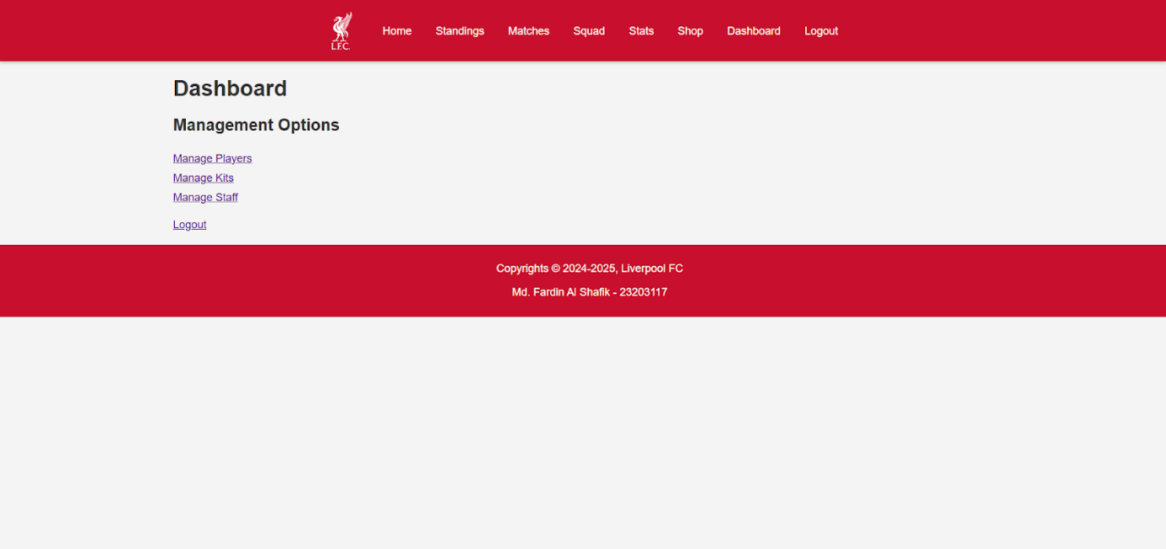
Figure 8: Dashboard

Coursework No. 12: Login & Logout System

Problem Statement
Implement authentication and role-based access.

Solution
<?php
require '../config/db.php';
require '../includes/functions.php';

$error = '';
if ($_SERVER['REQUEST_METHOD'] == 'POST') {
$username = clean($_POST['username']);
$password = $_POST['password'];

$query = $pdo->prepare("SELECT * FROM users WHERE username = ?");
$query->execute([$username]);
$user = $query->fetch();

if ($user) {
if (password_verify($password, $user['password_hash'])) {
$_SESSION['user_id'] = $user['user_id'];
$_SESSION['role'] = $user['role'];
$_SESSION['team_id'] = $user['team_id'];
header('Location: dashboard.php');
exit;
} else {
$error = "Password incorrect!";
}
} else {
$error = "Username not found!";
}
}
?>
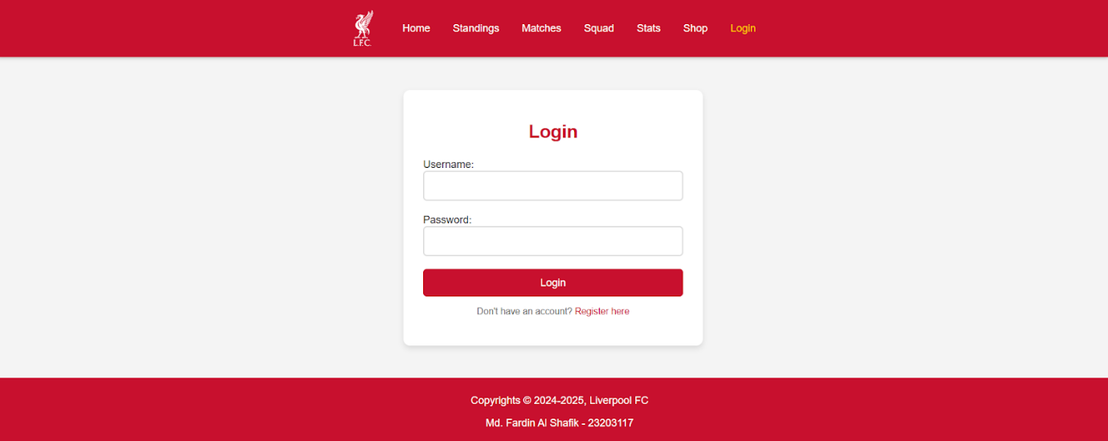
Figure 9: Login
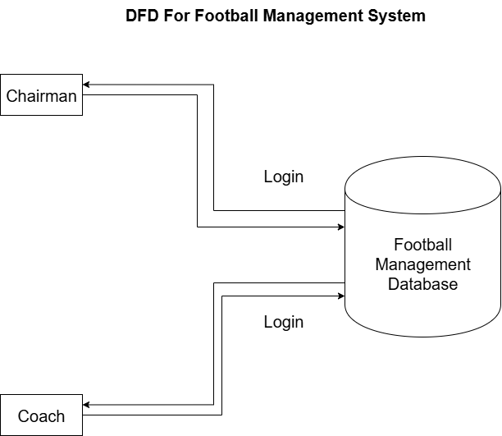
Figure 10: DFD 0

Ethical Considerations
Developing and deploying a Football Management System involves several ethical aspects, particularly in the context of data collection, storage, and use. As a database-driven system, it is essential to ensure that ethical guidelines are followed to protect stakeholders, users, and data integrity.

Data Privacy
Confidentiality of User Data: User credentials and personal information (such as email) are stored securely with hashing and access control. No unauthorized person should be able to access sensitive data.
Minimal Data Collection: Only the necessary information (e.g., usernames, staff roles, and team affiliations) is collected, ensuring that privacy is respected.

Security and Integrity
Prevention of Unauthorized Access: Role-based access ensures that coaches and chairmen only perform operations relevant to their responsibilities.
Integrity of Match and Player Records: It is ethically important to prevent manipulation of match results or player statistics. Database constraints and validation help maintain authenticity.

Fair Use and Transparency
Transparency in Operations: All updates (player records, injuries, matches) are logged to ensure accountability.
Avoiding Bias: Decisions regarding team performance and player statistics should be based on factual data and not altered for favoritism.

Professional Responsibility
Academic Integrity: The project was developed as part of a DBMS course and adheres to academic honesty policies.
Responsible Design: Care was taken to ensure that the system does not misuse data or expose users to risks.

Ethical Compliance in Future Development
If deployed in a real-world scenario, additional steps would be taken:
- Compliance with data protection regulations (such as GDPR).
- Encryption of all sensitive communication.
- Regular audits to ensure ethical standards are upheld.
By considering these ethical dimensions, the Football Management System not only serves its functional purpose but also aligns with broader responsibilities of fairness, accountability, and respect for privacy.

Learning Outcomes
Working on the Football Management System provided significant learning opportunities in both technical and professional aspects. The following outcomes summarize the key knowledge and skills gained during this project.

Understanding of DBMS Concepts
- Relational Model: Designed normalized tables with primary and foreign keys to ensure referential integrity.
- Constraints: Implemented NOT NULL, UNIQUE, and CHECK constraints to enforce valid data.
- Joins and Relationships: Learned to connect multiple tables using INNER JOIN, LEFT JOIN, and self-referencing joins (e.g., matches with opponent teams).
- Normalization: Applied normalization techniques to reduce redundancy and improve efficiency.
- Transactions and ACID Properties: Ensured consistency and reliability of database operations.

SQL Query Skills
- Developed complex SQL queries for retrieving player statistics, match summaries, and team performance.
- Practiced CRUD (Create, Read, Update, Delete) operations across all system modules.
- Wrote aggregate queries (SUM, AVG, COUNT) for generating reports.
- Gained experience in indexing and query optimization for faster performance.

System Design and Analysis
- Gained practical experience with Data Flow Diagrams (DFDs), ERD, activity diagrams, swimlane diagrams, and sequence diagrams.
- Learned how to translate real-world requirements into structured models.
- Understood the importance of role-based access and modular design in system architecture.

Programming and Implementation
- Used PHP for server-side logic and MySQL for database integration.
- Learned to handle form data, session management, and authentication in web applications.
- Understood the importance of secure password storage using hashing.
- Implemented validation to reduce runtime errors and improve data reliability.

Quality Assurance and Testing
- Designed and executed manual test cases to validate system correctness.
- Practiced debugging and refining queries and PHP scripts.
- Learned systematic approaches to error handling and input validation.

Ethical and Professional Lessons
- Understood the importance of protecting sensitive user data.
- Recognized the role of fairness and accountability in data-driven systems.
- Practiced professional reporting and documentation, which are essential for academic and industry work.

Chapter 7: Conclusion
The Football Club Management System was developed as a comprehensive database-driven application to manage teams, players, staff, matches, injuries, and shop operations. Through the use of MySQL as the database, PHP as the server-side language, and structured analysis and design methods, the project successfully demonstrated how database management principles can be applied in real-world scenarios.
The system addressed the key requirements identified at the beginning:
- Provided role-based access for chairman and coach with secure login.
- Enabled efficient management of players, teams, staff, and injuries.
- Allowed coaches to update match results and performance statistics.
- Facilitated shop management with inventory tracking.
- Maintained integrity and consistency across all modules through relational constraints.
From a learning perspective, the project strengthened understanding of database concepts such as relational schema design, normalization, joins, constraints, and queries. It also offered valuable experience in connecting front-end interfaces with back-end databases, testing for quality, and ensuring ethical practices such as data privacy and fairness.

Limitations
While the system achieved its primary goals, certain limitations remain:
- The interface is basic and can be improved for better user experience.
- Currently limited to two roles (Chairman and Coach); future expansion could include fans, analysts, or administrators.
- Reports are text-based and could be enhanced with visualizations and dashboards.
- Testing was mostly manual; automated testing could provide more robust validation.

Future Scope
- Advanced Analytics: Integrating data visualization tools (charts, graphs) to provide deeper insights into team and player performance.
- Mobile Support: Creating a mobile-friendly version or a dedicated app for easier access.
- Scalability: Expanding the system to manage multiple leagues or tournaments.
- Enhanced Security: Implementing two-factor authentication and stronger encryption.
- Automated Testing: Adding systematic automated test suites to ensure reliability.

In conclusion, the Football Management System not only fulfills the course objectives but also provides a practical foundation for applying database management skills in larger, more complex applications. It demonstrates the importance of structured design, systematic testing, and ethical responsibility, all of which are essential skills for future roles in data analysis and software development.

Referencing
- Elmasri, R., & Navathe, S. B. (2016). Fundamentals of Database Systems (7th ed.). Pearson.
- Ramakrishnan, R., & Gehrke, J. (2003). Database Management Systems (3rd ed.). McGraw-Hill.
- Silberschatz, A., Korth, H. F., & Sudarshan, S. (2019). Database System Concepts (7th ed.). McGraw-Hill.
- W3Schools. (n.d.). PHP Tutorial. Retrieved from
https://www.w3schools.com/php/
- W3Schools. (n.d.). MySQL Tutorial. Retrieved from
https://www.w3schools.com/mysql/
- GeeksforGeeks. (n.d.). DBMS Tutorials. Retrieved from https://www.geeksforgeeks.org/dbms/
- PHP Manual. (n.d.). PHP Documentation. Retrieved from
https://www.php.net/docs.php
- MySQL Documentation. (n.d.). MySQL Reference Manual. Retrieved from https://dev.mysql.com/doc/

